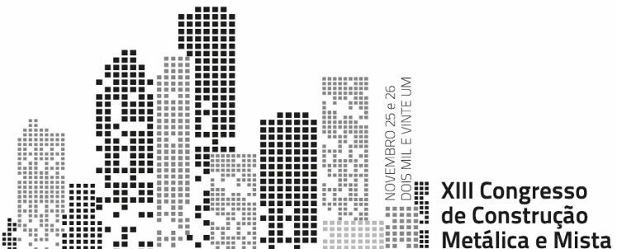
TITLE OF THE COMMUNICATION
Author 1^{a,*}, Author 2^{b} and Author 3^{c}
^{a,b} Institution of authors 1 and 2
^{c} Institution of author 3
* Author for contact. Tel.: xxx xxx xxx; E-mail: xxxxxxxxx
Abstract

Authors should submit 200 to 300 word abstracts, which must not exceed one A4 page. The abstracts must approach relevant information on the contents of the presentation, including the conclusions.
All papers concerning analysis, behaviour, design and construction of structures in steel, aluminium and composite steel-concrete will be analysed for oral presentation.
The abstracts are to be submitted through the website of the conference until 18th June 2021. The files to attach during the submission should be, preferably in MSWord (.doc) or Portable Document Format (.pdf). The name of the file must include the initials and the last name of the corresponding author (ec.: JFPires.doc). The file must also include the contacts of the corresponding author (phone and email).

