**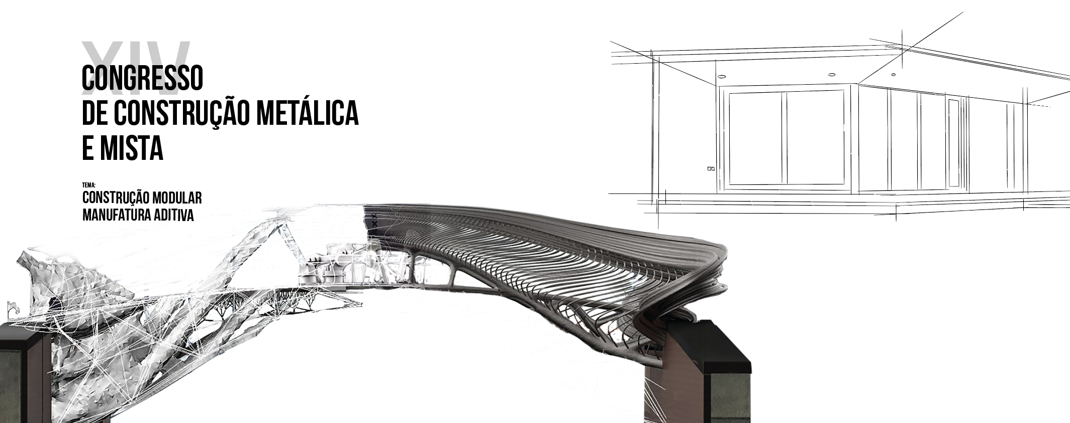**

**TITLE OF THE COMMUNICATION**

Author 1a, Author 2b e Author 3c

a,b  *Institution of authors 1 and 2*

c *Institution of author* 3

**Abstract**: The abstract must have the synthesis of the communication’s content and it mustn’t exceed 8 lines of text.

1. **Introduction**

The papers should be written in Portuguese (preferably), English or Spanish . Each paper should not exceed 10 pages, including text, figures and tables.

The papers are to be submitted through the website of the conference until 8th September 2023, and the files should be identified with the reference XIVCMM\_PT\_ the initials and the last name of the corresponding author (ex.: XIVCMM\_PT\_JPires.doc). The files should be submitted simultaneously in two formats: MSWord (.DOC or .DOCX) and Portable Document Format (.PDF).

1. **General Instructions**

The papers must be elaborated according to the indications given in this template. In order to simplify the authors work, this file contains all those indications.

The text in the papers should be presented in A4 format, with the following margins (i) top margin 2,5 cm; (ii) bottom margin 2,5 cm; (iii)left margin 2,5 cm and (iv) right margin 2,5 cm. The text to be published in the book of proceedings will be reduced in about 80% of the original. The whole text is to be written with single spacing, using Times New Roman font, size 12.

1. **Title, authors, institution and abstract**

The first page includes the title of the paper, the names of the authors and their institutions, and an abstract. The following vertical spacing must be used:

1. between the logo and the title: 60 pt;

2. between the title and the names of the authors: 24 pt;

3. between the names of the authors and their institutions: 12 pt;

4. between the institutions and the abstract: 36 pt.

**3.1 Title of the paper**

The title of the paper should be centred, in capital letters, Times New Roman font, size 14, in **bold.** In case there is more than one line of text, single spacing must be used.

**3.2 Names of authors and institutions**

The names of the authors should appear under the title of the paper, with a vertical spacing of 24 pt, centred in the same line of text. The names should include the first name, the initials of the middle names and the last names (ex.: Maria M. Gil Maia, António C. F. Mateus). The institutions of the authors should appear under the names, with a vertical spacing of 12 pt, centred, size 10 letters in *italics*.

**3.3 Abstract**

The abstract must have the synthesis of the communication’s contents and it mustn’t exceed 8 lines of text. It should appear under the institution of the last author, with a vertical spacing of 36 pt. Two blank lines should be kept before the “Introduction”. The abstract should be written in size 12 letters, and the text should be justified. The word “**Abstract**”, also written in size 12, **bold**, appears at the beginning of the first line.

1. **Sections**

**4.1 Main sections**

The titles of the main sections should be written in small letters, the first letter being capital, size 14, **bold** and aligned to the left. Before a main title, two blank lines should appear, while after the main title one blank line must be kept.

.

**4.2 Secondary sections**

The titles of the secondary sections should be written in small letters, the first letter being capital, size 12, **bold** and aligned to the left. Before a secondary title, two blank lines should appear, while after the secondary title one blank line must be kept.

**4.2.1** Tertiary sections

The titles of the tertiary sections should be written in small letters, the first letter being capital, size 12, normal and aligned to the left, without indent. Only the number of the section appears in **bold.** Before a tertiary title, one blank line must be kept.

**4.2.2** Footnotes

Do not include footnotes in the text of the paper.

1. **Text**

The text of the paper is written with single spacing, justified, with Times New Roman font, size 12. The first line of the first paragraph of each section or sub-section is not indented, but the first lines of all other paragraphs are indented by 0,5 cm. No blank lines are to be left between paragraphs.

The paper should include an introduction and the final conclusions.

1. **Equations, figures and tables**

**6.1 Equations**

The equations must be centred in the text and must be numbered. The numbering should appear in the same line of the equation, with a number between brackets and aligned to the right. The equations are written in Times New Roman font, size 12.

Every time there is the necessity to mention an equation in the text, the following notation must appear: Eq. (x). For example “(…) The condition expressed in Eq. (2) is only verified (…)”. Example of equation:

 (1)

No blank lines are to be left before or after the equations.

**6.2 Figures and tables**

The figures and tables should be centred in the text and numbered sequentially. All figures and tables should be included in the text, in single-spaced paragraphs. The tables and the figures should not appear at the end of the paper.

**6.2.1** Tables

The tables must be captioned. Captions should appear above the tables, centred in text, in Times New Roman, size 11. One blank line must be left between the text and the table subtitle and another blank line must appear after the table. No blank lines are to appear between the table and its subtitle. Example:

## **Tabela 1:** Legenda

|  |  |  |
| --- | --- | --- |
| Teste | *ke*.0 (kN/mm) | *FRd* (kN) |
| T1 | 75.95 | 67.02 |
| P15 | 132.00 | 80.73 |

All tables must be referred to in text as “Table x”.

**6.2.2** Figures and photos

All figures and photos must be captioned. Captions should appear under the figures, centred in text, in Times New Roman font, size 11. The photos should appear in black and white, and they should have an appropriate quality for printing. One blank line should be left before the figure, and another must be left after the caption, before the text. Between the figure and its caption there should be no blank lines.

Examples:

|  |  |
| --- | --- |
|  | Fig 23(EEP_10_2a) |
| a) Example 1 | b) Example 2 |

**Fig. 1:** Subtitle



**Fig. 2:** Subtitle (example for a graphic)

All figures must be referred to in text as “Fig. x”.

1. **Conclusions**

The paper must have a section for final conclusions, preferably presented the following way:

The main conclusions are:

1. conclusion 1;
2. etc.

The authors should respect the formatting rules presented in this document. We suggest that you use this template, which is already formatted according to the mentioned rules.

**Acknowledgments**

The authors can include an acknowledgment section, after the conclusions. These sections should not be numbered.

**Notation**

## All notations must be mentioned in the text. The variables should be written in *italics*, except for Greek capitals, which should be written in normal style. If necessary, a list of notations can be created (section not numbered), before the “References” section. In that case, the following format should be used:

|  |  |
| --- | --- |
| *b* | Width |
| *e* | Distance |
| *E* | Young’s Module |
| *b* | Screw stretching |
|  | Axial stretching |

**References**

The references should appear at the end of the paper, under the title “References”. This section is not numbered. Along the text, the references are marked with a number between square parentheses. As example: “(...) The numeric model that is described in literature [1,2] and covers the analysis (...)”.

The quotes are mentioned by their order of appearance in text, in Times New Roman font, size 12. No blank lines are to be left between references. Some examples for the format of the references can be found below:

[1] Weynand K, Jaspart JP, Steenhuis M. “The stiffness model of revised annex J of Eurocode 3”, *Proceedings of the 3rd International Workshop on Connections* (Eds.: R. Bjorhovde, A. Colson, R. Zandonini), Trento, Itália, 441-452, 1995.

[2] Zoetemeijer P. “A design method for the tension side of statically loaded bolted beam-to-column connections”, *Heron*, 20(1), 1-59, 1974.

[3] Owen DRJ, Hinton E. *Finite elements in plasticity – theory and practice*, Swansea: Pineridge Press Limited, 1980.